TwentyThreeAndMe registration

Made 17.07.2018.

To use the API of 23andMe, you will need to generate API credentials.

1. Go to the developer page of 23andMe at <https://api.23andme.com/> and click on button: Developer SignUp.

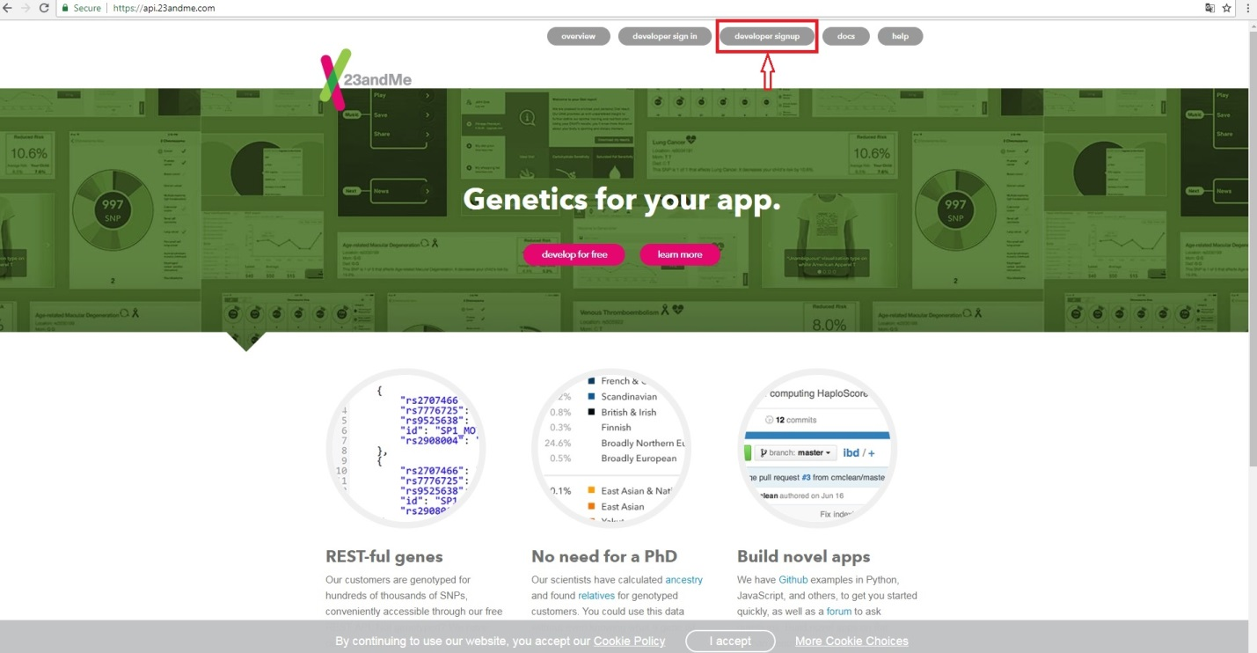

1. For create developer account you have to enter your personal data and click button: Create account.

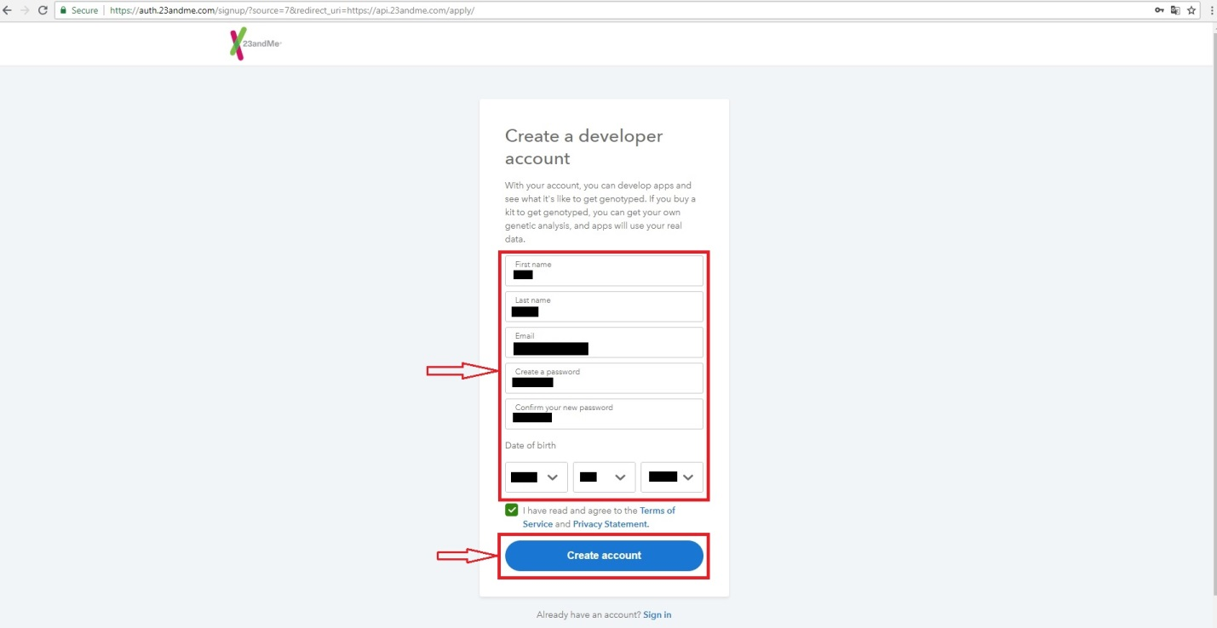

1. When your developer account is created, you will see information about confirm your e-mail.

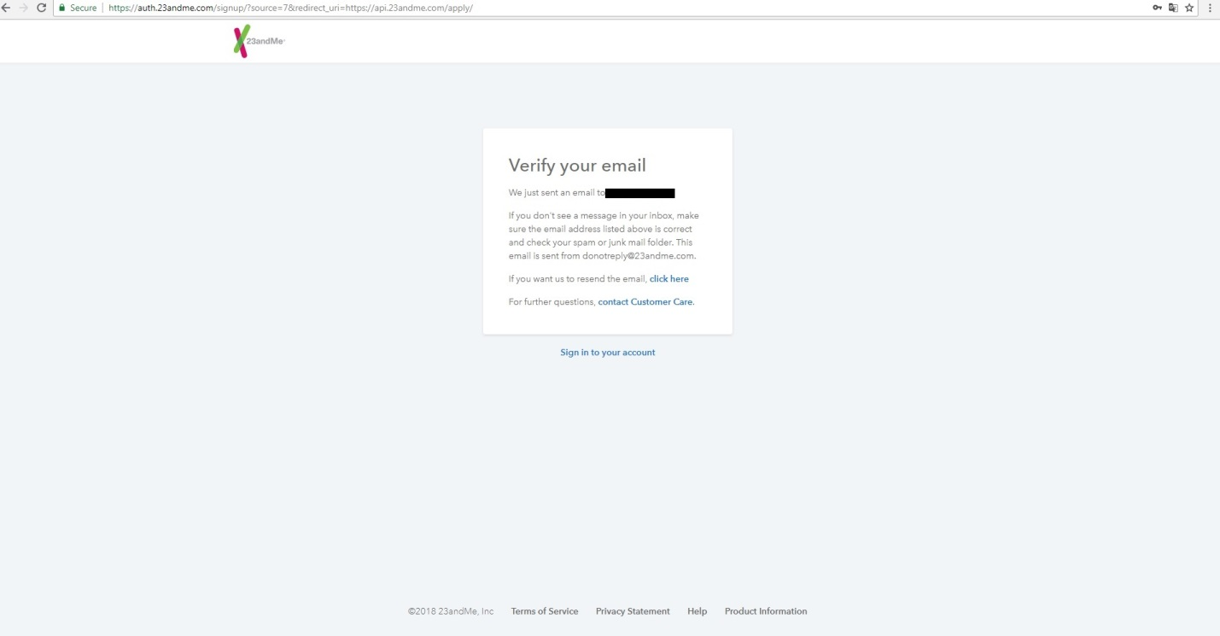

1. You have to enter in your e-mail account and to confirm your e-mail.

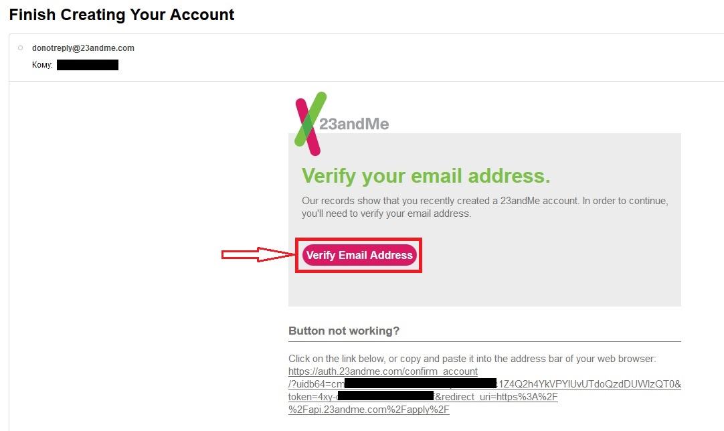

1. After confirming you e-mail, you have to enter data about your App and click button: Create my client.

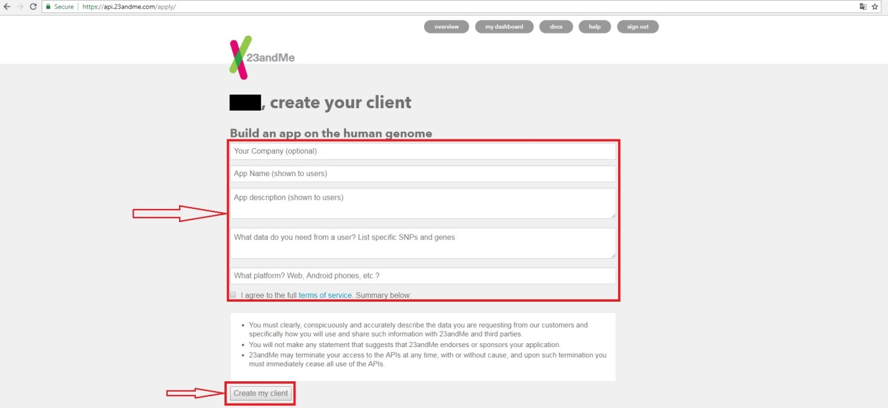

1. After that you can see your client_id and client_secret. And you can edit information about your API Client.

